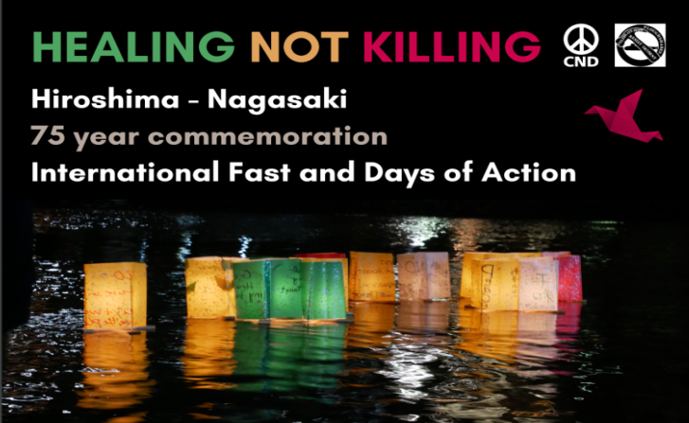
5th July 2020

Hiroshima-Nagasaki Fast
Thursday 6th – Sunday 9th August

Dear TP supporter

To reduce possible health risks during the Covid-19 pandemic we’re recommending TP supporters don’t travel long distances but organise local peace events in small groups to mark the 75th anniversary of the nuclear bombings of Japan. This remembrance could take the form of public or private fasting during the period Thursday 6th until Sunday 9th August, days-of-action, media outreach, or other memorial events. People have already expressed interest in several locations across the UK including London, Edinburgh, Bristol, Iona, Knighton, Plymouth, Barnstaple, Oxford, Glasgow and others to follow.

All plans should be adaptable and compliant with current Covid-19 Government regulation

Here’s a list of possible activities but we’re sure groups will also develop their own creative ideas:-
Visual Information – could be decorations, banners, flags, information boards, etc.
Vigils – visible witness to engage the public, etc.
Public performance and ceremonies – could be music, poetry, song, samba bands, religious, secular, etc.
Die-ins – could be at 08.15 on Thursday 6th and 11.01 on Sunday 9th August to mark the times of the bombings.
Talks & workshops – good to use local speakers and activists.
Public presence – could be information stalls in a town centre, community centre, church, park, etc.
Public Participation – could be signing letters/postcards, petitions, a “wish-tree” or other symbols.
Craftivism – making origami “cranes”, peace lanterns, sewing peace flags, making badges, etc.
Actions – some people may wish to picket an army recruitment office, arms factory, make a presentation to a local elected representative, or a procession to the town hall to lobby for “Mayors for Peace” etc etc.
Local Media Work – this will be a very important aspect to inform local people and to build our movement.

Social media – we’re new to this but keen to build a social media presence which is dynamic and informative. We’ve set up a general UK-wide facebook event on the Trident Ploughshares page called “Hiroshima Nagasaki Fast UK”. We hope each locality will also set up their own facebook “event” to promote their local arrangements, please name “Trident Ploughshares” as a “co-host” so we can link up easily. We would love to see groups across the country posting photographs, videos, memes, etc. We could also link-up during the fast using online video conferencing such as Zoom, Jitsi, etc, and maybe link ups with other groups internationally.
Literature - we’re mailing examples of the postcards called HEALING NOT KILLING, TOGETHER WE MUST STOP TRIDENT and BRITAIN’S CURRENT NUCLEAR WEAPONS SYSTEM plus a 2-fold A4 flier called “HOW TO CLOSE DOWN A NUCLEAR BOMB FACTORY”. Pictures of these can be found on the Trident Ploughshares website http://tridentploughshares.org/ under the “Publications” tab and “Leaflets”. Please order promptly to allow time for delivery.
https://xrpeace.org/ has an excellent selection of new fliers/factsheets if you have local printing

Online resources and useful information are also available at www.nukewatch.org.uk/ and https://cnduk.org/
The public really need to hear about the U.N. Treaty on the Prohibition of Nuclear Weapons and www.icanw.org are preparing further useful resources.

Fund-raising – we’re considering a crowd-funder to help cover expenses and this may appear in due course.

For all correspondence contact Michal Lovejoy (michal@calstock.org.uk & 01822-834452). Please let us know if you are willing to coordinate the event in your locality or if you want to join with others and we will link you up.

Thank you for working for a peaceful and nuclear-weapons free world……………………………..……..Row in Bristol

